
SOP Title: | eCommerce Returns Exceptions Processing
Document Storage Location: | STACS/Management/SOPs – Logistics and Warehousing | Document #: | SEASOP3436v100
SOP Originator: | Erwin Dela Pena | Last Edited by: | Erwin Dela Pena
Effective Date: | 08/04/2021 | Last Edited Date: | 12/18/2023
Other: | Visibility, Nerp, and Workbench access required.

- Purpose
  - To outline exceptions to standard customer refusals and RMAs (Return Merchandise Authorization) process, which should be processed within 5 business days.
- Scope
  - Coppell eCommerce (eComm): All refusals and RMAs sold through Samsung.com.
- Responsibilities
  - The 3PL eComm team (3PL) shall be responsible for the systemic 3PL WMS processes and physical activities within eComm Operations.
  - The SEA Logistics, Planning & Shared Services eComm team (LPS) shall provide oversight for 3PL and validate performance.
  - The 3PL and LPS teams shall collaborate on troubleshooting procedures for processing exceptions to standard customer returns/refusals.
  - The SEA Warehouse Claims team (Claims) shall file claims with the carrier for full and partial customer refusals.
  - The SEA Security team shall receive and investigate returns/refusals exceptions classified as Unsent or Suspected Fraud.
- Instructions
- Exceptions Information
  - Exceptions are organized onto three carts on the returns floor.
    - The Misshipments cart holds exceptions classified as Misshipments.
      - Misshipment: Customer received the incorrect product and shipped it back.
      - Exceptions should be closed out by EOD.
    - The Categorized Exceptions cart holds exceptions separated into different exception types.
(all exceptions other than Misshipments)
      - Exceptions should be closed out by the end of the day (EOD).
    - The Days-of-The-Week Exceptions cart holds those exceptions not resolved by EOD.
      - The cart is divided into 5 bins for each day of the week.
      - Each day’s pending Exceptions at EOD are placed in their respective day’s bin.
      - 3PL and LPS work together to close out Exceptions within one week.
  - 3PL maintains an Exceptions Report (Excel file) containing a daily log of exceptions received.
  - 3PL sends Exceptions quantity to LPS daily via the daily report.
- Returns and refusals are processed under standard processing procedure.
(See Returns Processing and Refusals Processing SOPs for more details.)
  - 3PL performs dock scan and arrival scan of the product.
  - 3PL receives the return or refusal, inspects the product and product box, and locates the RMA or purchase order ID (PO ID) as required.
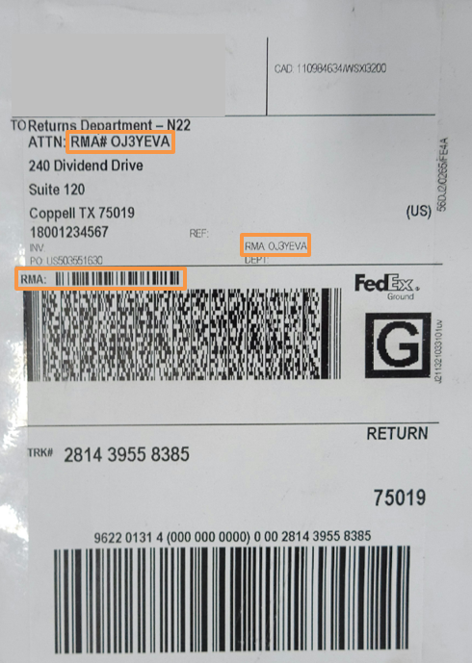
    - If the return or refusal cannot be received, follow the appropriate Exceptions Processing protocol below instead of the standard processing protocol.
The RMA can be found on the shipping label on the package.

- High Importance Exceptions
  - Unsent: If a return is in the original box but is missing some of the original items.
Empty Box: If a return is in the orginal box but is missing ALL of the original items.
    - Upon inspection, 3PL finds the original product box is missing items.
    - 3PL also inspects the package box to determine if it has been tampered with.
      - If the return is determined to have been tampered with the 3PL gives the return to LPS and a claim is filed with the claims team.
    - If original product box is missing some items
      - 3PL processes the exception as Unsent.
      - 3PL logs RMA onto the Exceptions Report as ‘Unsent’.
      - 3PL closes out the RMA in their Warehouse Management System (WMS) on same day.
      - 3PL marks the exception as closed on Exceptions Report.

    - If original product box is missing all items
      - 3PL processes the return as an empty box.
      - 3PL logs missing items onto Exceptions Report as ‘Empty Box’.
      - 3PL closes out the RMA in their WMS (Warehouse Management System) on same day.
      - 3PL marks the exception as closed on Exceptions Report.
Packages classified as Unsent are moved to the designated Unsent location on the returns floor.

  - Suspected Fraud
    - If a suspected fraud item is identified, 3PL will process the RMA as Unsent or Empty Box
    - Common suspected fraud indicators:
      - Delivery address on shipping label is not 240 Dividend Dr. (Coppell Warehouse).
      - Font on shipping label has been altered.
      - Box does not contain Samsung product.
      - Customer’s address in Workbench does not match ‘From’ address on shipping label.
        - Customer lives in Georgia, but the package was shipped from Louisiana.
      - Package type does not match product type.
        - Return phone was shipped in a small packing envelope instead of in a box.
    - 3PL passes suspected fraud package to LPS.
    - LPS investigates and passes suspected fraud package information to Risk Management.
    - LPS logs package onto local Fraud report.
    - 3PL closes out the product RMA as Unsent in 3PL WMS.
- Inventory Exceptions

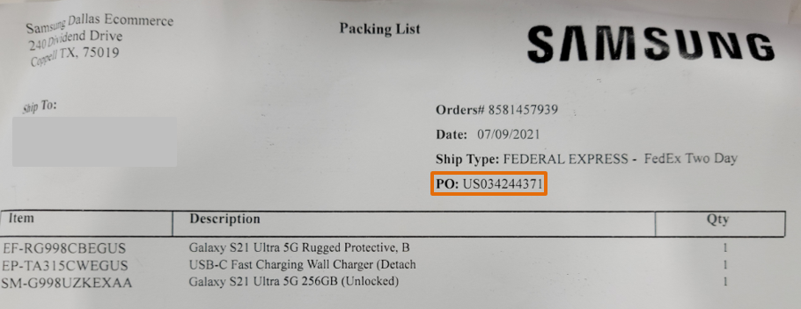
PO ID can be found on refusal packing list inside of package.

  - Empty and Partial Refusal: Customer refusal is missing some items from package or all items from the package.
    - 3PL does not see an RMA on package shipping label.
    - 3PL does not find some or any of the product in box.
    - 3PL validates product was part of inventory using product S/N or IMEI as applicable.
    - If an empty box or partial refusal has been identified, the 3PL will not process.
    - 3PL logs the refusal onto the Exceptions Report as a partial refusal or empty box.
    - 3PL provides the LPS with the refusal package.
    - LPS will provide photos and the report to the Claims team so a claim can be filed with FedEx.
      - Reference FedEx Refusals & Tampered Box Claims SOP.
      - Send to Claims team: IMAuditTeam@sea.samsung.com
    - Once the claim has been submitted, the LPS returns manager will pass the refusal to the 3PL to process as an unsent or empty box for the missing items and put away items not missing in 3PL WMS.
    - 3PL will close out the refusal in the exception log by stating in the comments the close date.
    - 3PL puts away refusal material on warehouse floor.
  - Partial Refusal SIM card processing:
    - For all partial refusals where a SIM card is part of the return, validate that the SIM card in the box.
    - If more than just the SIM card is missing, STOP and hand the partial refusal to the LPS team so a claim can be filed per the directions in section 2.
    - If it is verified that the SIM is the only item missing, do not process as an unsent but process as a normal return.
    - During processing the missing SIM card will need to be moved to the SIMVECO bin which is a virtual bin.
    - All item from that refusal processing can be put away as normal.
    - Inventory control will review the SIM bin and make adjustments as needed.
  - Misshipment (Reference Misshipment SOP for detailed processing.)
    - 3PL compares the RMA packing list to the product in the box.
    - 3PL validates the SKU and IMEI or S/N as required.
    - If the RMA packing list and the received product do not match, 3PL researches if the product received is on another RMA.
      - If the return is on another RMA, 3PL closes out that RMA.
      - If the return is not found on another RMA, 3PL closes out original RMA (on product in box).
        - 3PL receives the RMA as is.
        - 3PL puts away received product in Misshipment bin location on warehouse floor.
    - 3PL labels the closed RMA as ‘Misshipment’ on the Exceptions Report.
    - The LPS Inventory team reviews the Misshipment on the Exceptions Report.
    - The LPS Inventory team creates a PUMI (approval request) to adjust Misshipments as required.
    - Once the PUMI has been approved, 3PL is notified to put away the item.
    - The item is closed out on the Exceptions Report.
    - 3PL closes out the exception in 3PL WMS as a Misshipment at EOD.
- RMA Exceptions
  - Not on RMA: Product is returned but is not on the RMA.
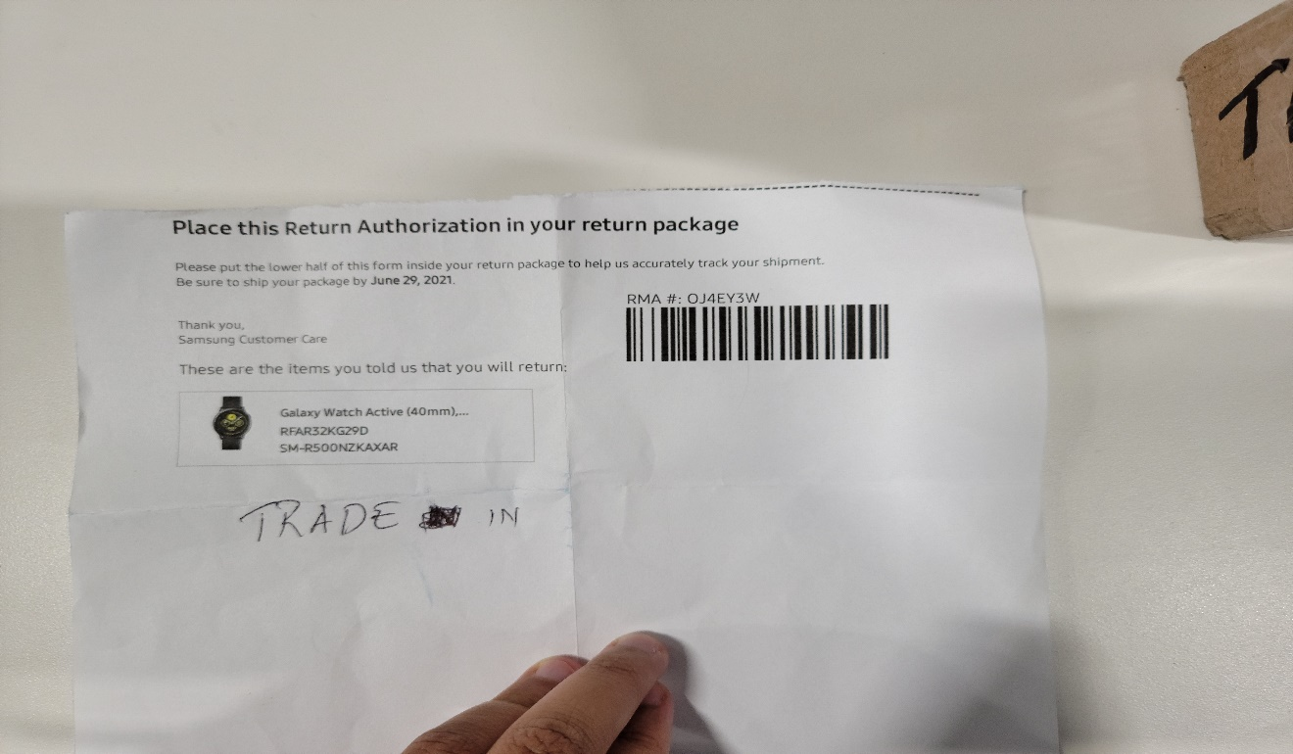
    - 3PL compares the RMA packing list to the product in the box.
RMA packing list can be found inside of package.
    - 3PL validates the SKU and IMEI or S/N as required.
    - If the RMA packing list and the product received do not match, 3PL researches if the received product is on another RMA for the same customer.
      - If the product is on another RMA, process the product under the correct RMA.
      - If the product is not on another RMA, 3PL validates if the SKU and IMEI have been part of inventory.
        - If the SKU and IMEI have not been part of eComm inventory
          - 3PL logs onto the Exceptions Report as ‘Not Our Item’.
          - The product is passed to LPS and is RTC (Returned to Customer).
          - The RMA is closed under disposition code UNP
        - If the SKU and IMEI have been part of inventory, 3PL creates and processes a new RMA.
          - A new RMA requires a one hour wait time for the RMA to sync with 3PL WMS.
      - The incorrect RMA is listed on the Exceptions Report as ‘RMA Mismatch’. The incorrect RMA will be closed using disposition code UNP for items not found in the RMA.
    - If the SKU matches the RMA but the S/N does not
      - 3PL determines if the product has been part of eComm inventory.
        - If the product has been part of eComm inventory
          - 3PL closes out the RMA in 3PL WMS and uses disposition code ISN
          - The product is returned to inventory.
        - If the product has not been part of eComm inventory
          - 3PL closes out the RMA as UNP in 3PL WMS.
          - 3PL logs it onto the Exceptions Report as ‘Not Our Item’.
          - The product is passed to LPS for RTC (returning to customer).
  - RMA Not Working: The RMA cannot be processed.
    - If the RMA cannot be processed, 3PL provides the information to LPS for review.
    - LPS provides a new RMA.
    - 3PL closes out the new RMA in 3PL WMS.
      - If further issues are presented, 3PL IT or LPS will be notified and will try to correct the issue.
    - The RMA that does not work is closed out with a disposition code of EBX.
    - The return is logged onto the Exceptions Report as ‘RMA Not Working’ during resolution.
    - The return is marked as closed after resolution.
  - RMA Mismatch: RMA on the shipping label is incorrect; RMA on the packing list inside of the box is correct.
    - If two different RMAs are found
      - 3PL checks their WMS to determine correct RMA.
      - 3PL processes the return using the correct RMA.
      - The incorrect RMA is closed out with a disposition code of EBX.
      - The incorrect RMA is logged onto the Exceptions Report as ‘RMA Mismatch’ and closed out as Unsent.
      - 3PL will mark the exception as closed and include the correct RMA processed in the notes of the Exceptions Report.
    - RMA is closed out in 3PL WMS within 24 hours.
- Not an eComm Item
  - Trade-In: Customer sends the trade-in device to the Coppell location instead of to the trade-in vendor.
    - 3PL receives the return, inspects the product, and looks for documentation.
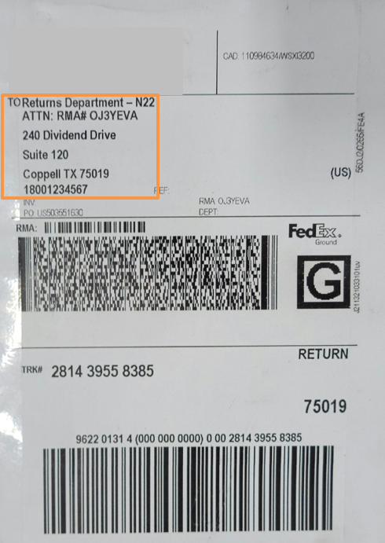

Shipping label shows Coppell warehouse address
(240 Dividend Dr.) instead of Trade-In center address.
Return documentation for Trade-Ins should be inside of returned package.

    - 3PL verifies if the product is part of inventory.
      - If the product is part of inventory
        - Use the IMEI to determine if an RMA exists.
          - If an RMA exists, process the return.
          - If an RMA does not exist, create new RMA.
          - The old RMA is closed out using EBX if there are no remaining returns that can be processed using that RMA number.
      - If the product is not part of inventory, pass to LPS to determine if the product is a Trade-In or RTC.
        - Review order information in Workbench
          - If order information in Workbench matches the product received, product is a Trade-In. Any open RMA associated with the trade in is processed closed with a TRD disposition code.
            - Print Trade-In label.
            - Log product onto the Exceptions Report as ‘Trade-In’.
            - Ship product to the Trade-In vendor.
          - If the order information in Workbench does not match product received, product is RTC.
            - Ship product back to customer.
  - Non-SEA or MPC item: RMA contains a product that is not from the Mobile division of SEA (Mobile) or that belongs to the Triage partner.
    - If the returned product is not Mobile’s or is a Samsung Consumer Electronics (CE) product
      - 3PL logs the product onto the Exceptions Report as ‘Not our item’.
      - 3PL closes out the exception in their WMS within 24 hours. It will be tagged with disposition code UNP.
    - 3PL checks the box for an MPC label.
      - If the returned product belongs to the MPC
        - 3PL passes the return to LPS to ship to the MPC.
      - If the returned product does not belong to the MPC
        - 3PL passes the return to LPS.
        - LPS prints shipping label for shipment back to customer (RTC).
- Missing Parts in a Hard Bundle: Item returned is missing items as part of a bundle kit.
  - 3PL validates the SKU and S/N or IMEI as required.
  - If bundle is missing items that were part of the bundle, 3PL processes under the disposition code of MSP.
  - The item is given to the LPS team and the item is shipped back to the customer.
- Customer Refusal Not Working: Customer refuses the item sent to them and the refusal cannot be closed out by 3PL.
  - 3PL validates the SKU and S/N or IMEI as required.
  - If the reverse delivery order (RDO) is not working or not found, the information is provided to LPS for research.
  - 3PL logs the refusal onto Exceptions Report as ‘Refusal not working’.
  - LPS provides a working RDO or RMA.
  - 3PL processes the refusal and puts away.
  - 3PL closes out the exception on the Exceptions Report.
- Cancelled Order: Product was shipped out but is returned due to customer cancellation.
  - 3PL performs dock scan and arrival scan of the product.
  - 3PL receives the return, inspects the product, and reviews the PO ID.
    - 3PL checks Workbench and 3PL WMS for order status.
      - Status shows order was ‘Cancelled’ by customer.
    - 3PL verifies the SKUs in 3PL WMS.
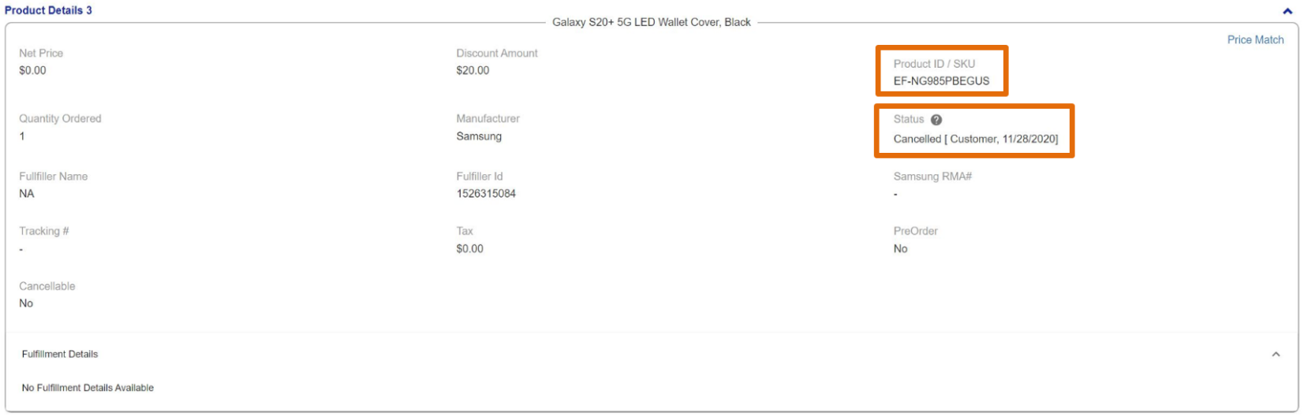
Check Workbench to check SKU and verify Status.
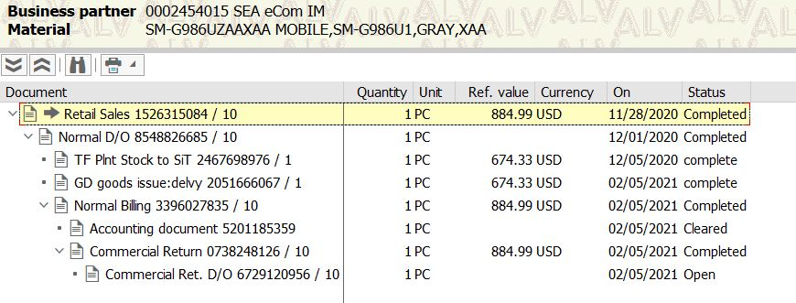
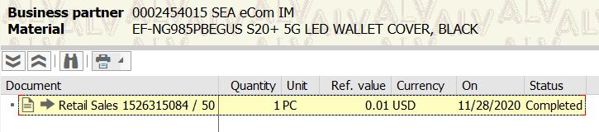
Example of completed order in GMP.
Example of cancelled order in GMP.

  - 3PL logs the product onto the Exceptions Report.
  - The LPS Inventory team reviews the cancelled order and provides instructions to 3PL regarding inventory adjustment as required.
    - The LPS Inventory team provides instructions for adjustments in 3PL WMS.
  - The product is closed out on the Exceptions Report after inventory adjustment is complete.
- Related Documents

